Here a simple TK-UI with XUL content which display XUL Button, Label, Texbox...
For the moment, TK-UI manage basic widgets because I'm refactoring it to use UFace as UI facade.

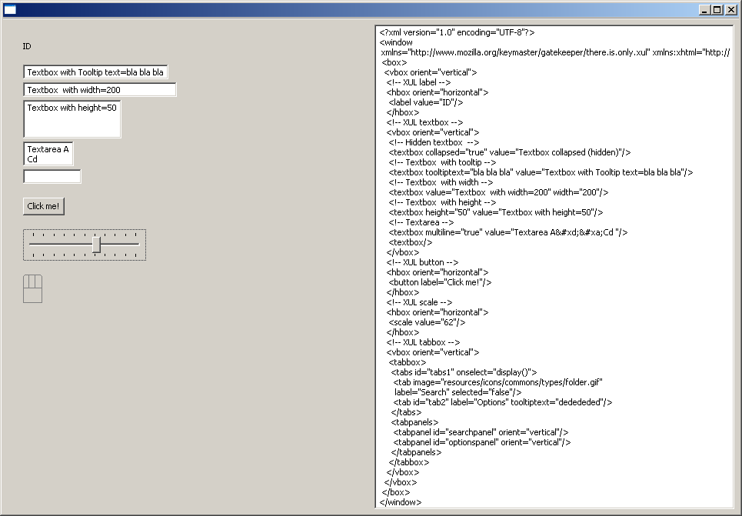
On the right screen you can see the XUL content and on the left screen you can see the SWT result of the XUL content.

The UI Element is totally bounded with DOM Element by using JFace Databinding.

The textarea wich display the XUL content is too bounded with DOM Document (by using JFace Databinding) which manage SWT render. (This sample use UFace JFaceFactory to render it to SWT) :

- So if you type XUL content into the textarea, it update DOM Document which refresh SWT renderer. You have Textarea => DOM Document => SWT render.

For instance if you type 5 into the value attribute of the XUL scale
the SWT scale is refreshed
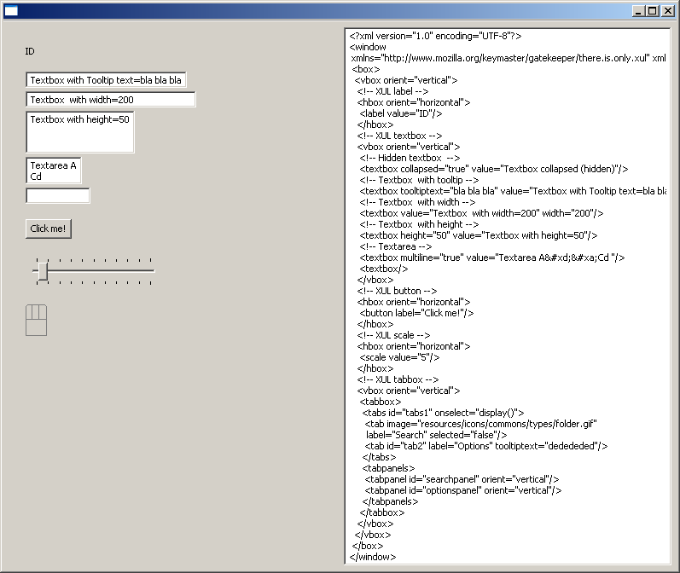

- If you move Scale, the DOM Document is updated and textarea is updated with new value of the XUL scale. You have SWT render => DOM Document => Textarea.

For instance if you move the slider the value attribute of the XUL scale is updated

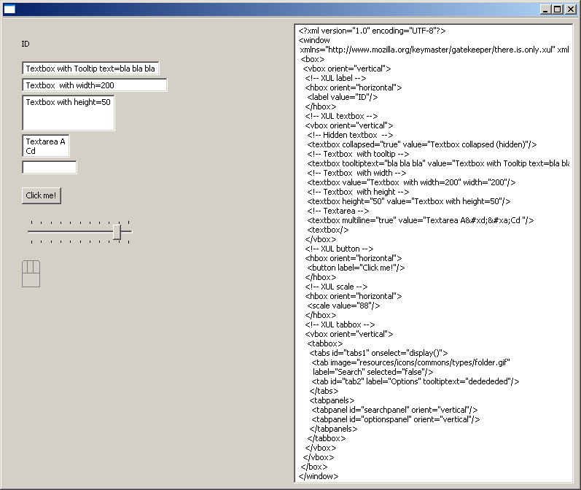

Layout is too bounded, So if you change the orient attribute of a XUL Box into textarea, SWT is refreshed. For instance if you type orient=horizontal into textarea the SWT layout is refreshed

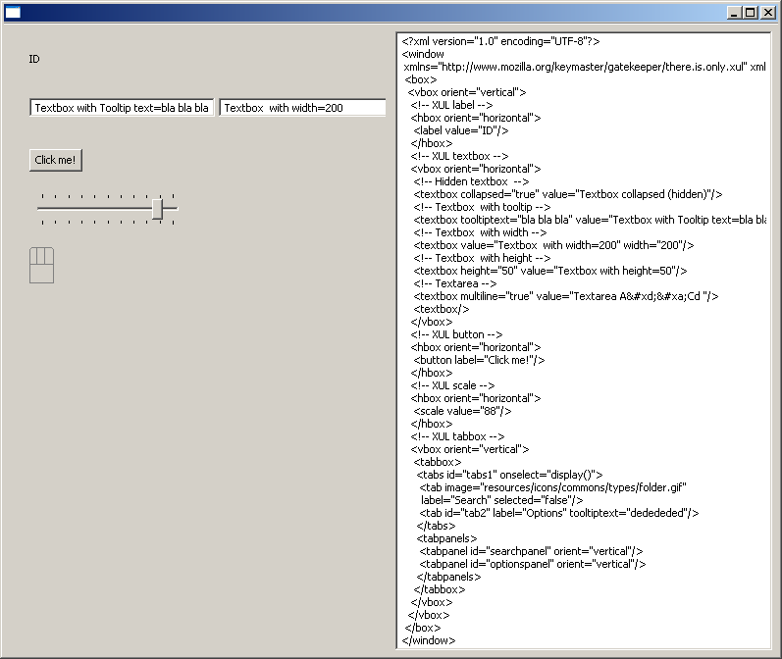

Layout Data is too bounded. So if you change the width attribute of XUL element into textarea, the SWT Text is resized. For instance if you type width=1000 into textarea the SWT layout data is refreshed

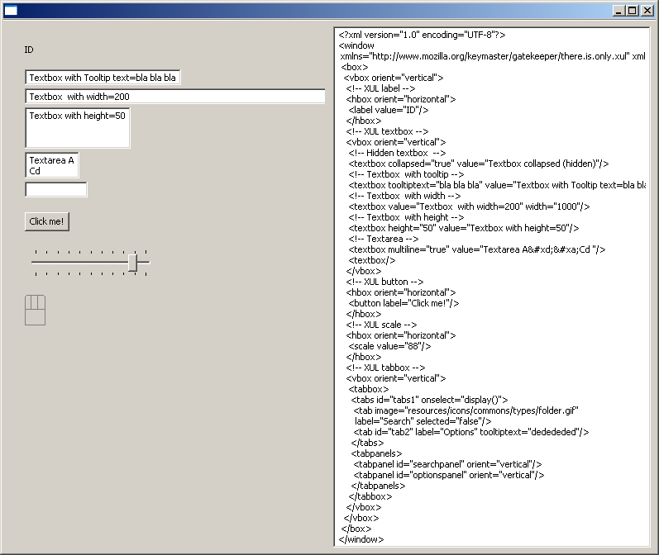

Internally TK-UI use UFace to manage render. So it's easy to have the same result with another render kit. Here the same sample with Swing :

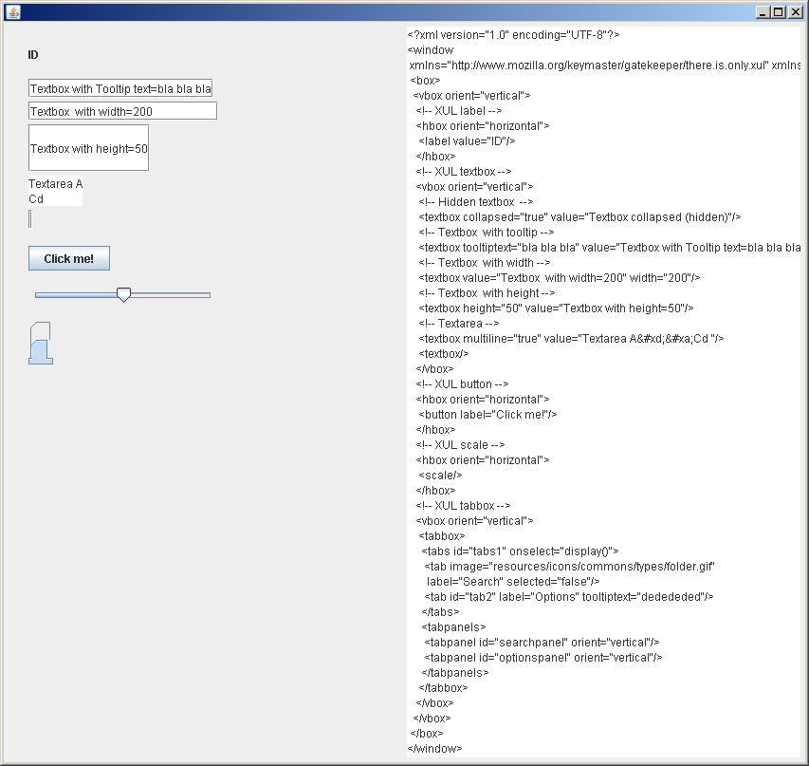
I try to have TK-UI API very simple:

UIComposite containerComposite = .... //(interface of UFace for composite which
// wrap native widget (SWT Composite,
// Swing Jpanel...) where you want
// attach the DOM Document)
// Get TK-UI platform which contains default configuration (XUL, XHTML element factories...your own XML markup factory (you can mix several XML markup)...)
IPlatform platform = Platform.getDefaultPlatform();
DOMDocument document = platform.createDocument(containerComposite);

// Get XUL, XHTML... inputstream
InputStream declarativeUIStream = ...

// Load DOM Document
platform.loadDocument(declarativeUIStream, document);

DBEL=Databinding Expression Language

TK-UI will support soon (I have already developped that but I'm restarting to use UFace UIForm and JXPath to manage Path), binding expression (like XAML expression, EL expression...)

So you will able to soon write this :

<listbox id="PEOPLE_TABLE"
items="{Binding Source=Model Path=People}" >
</listbox>

Here listbox is bounded with List of People JavaBean which was registered with key=Model.

<textbox value="{Binding ElementId=PEOPLE_TABLE Path=Id}" />

Here textbox is bounded with selection of the listbox. When you select a people into listbox, it will display the ID of the people selected (People#getId()).

I have intention to create the same demo like UFace but with declarative UI by using XUL, XHTML (for HTML table layout) and XAML expression binding.

